**DAY – 2 TASKS**

**1.Write a blog on the difference between document and windows objects.**

**DOCUMENT OBJECT:**

The HTML document that shows up in the browser window and functions as an interface for interacting with the content of the web page is known as the Document object. When a web page is loaded, the browser creates a Document Object Model of it.

The DOM is a logical tree in a document, with methods allowing programmatic access to change its structure, style, or content.

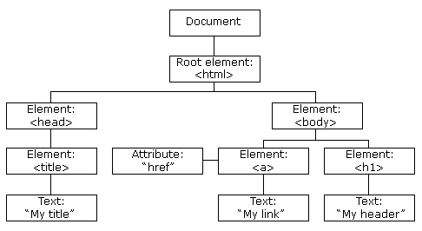

***Properties:***

element.innerHTML = new html content/*/Change the inner HTML of an element*

element.attribute = new value*//Change the attribute value of an HTML element*

***Methods:***

document.createElement(element*//Create an HTML element*

document.removeChild(element)*//Remove an HTML element*

***Windows Object:***

In client-side JavaScript, the Window object serves as the base of the document object model and represents the browser window that contains a DOM page. It is a global object.

Supported by all browsers, the window object automatically includes global JavaScript variables, objects, and functions as members and represents the window of the browser.

The Window object oversees controlling global variables, functions, and objects. It also offers browser interaction methods and oversees features like setTimeout(), setInterval(), confirm(), and alert() that are connected to windows, tabs, or frames.

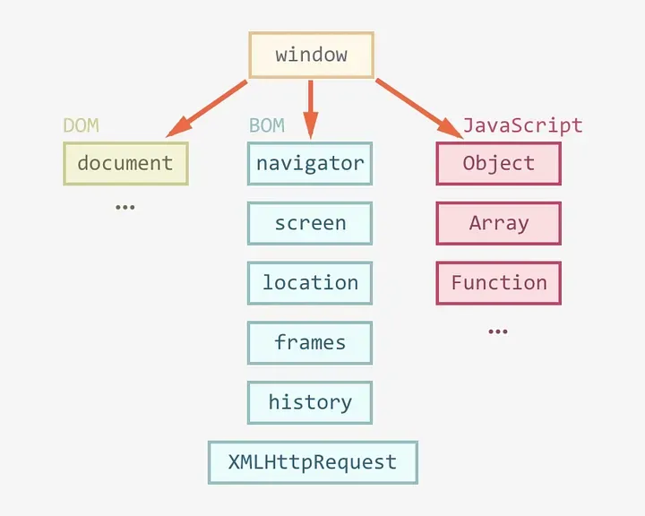

***Properties***

*window.innerHeight - the inner height of the browser window (in pixels)*

*window.innerWidth - the inner width of the browser window (in pixels)*

***Methods***

*window.open() - open a new window*

*window.close() - close the current window*

*window.moveTo() - move the current window*

*window.resizeTo() - resize the current window*